Pre-K Counts
1 2 3...

FREE Preschool

If your child will be three or four on or before school district cut-off date, now is the time to enroll your child in Pre-K Counts for this fall!!

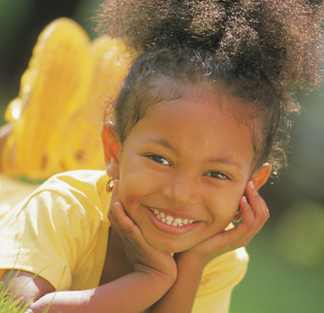
What can I expect from a Pre-K Counts Classroom?
Pre-K Counts offers quality preschool to help your child learn the skills they need to be ready and excited for kindergarten.
- Highly qualified teachers, with experience working with young children
- Small class sizes so your teachers have lots of time for your child
- A curriculum and learning activities that help your child grow academically and socially
- Review of your child’s development with teachers to help your child reach his promise
Who is eligible for PA Pre-K Counts?
PA Pre-K Counts is designed for children who:
- will be between age 3 and 4 on or before school district cut off date
- are at risk of school failure, either because of income (300% of the federal poverty level, or a family of four earning less than $78,600, language (English is not your first language), cultural or special needs issues
- Families must be Pennsylvania residents

For an application or more information, visit our website www.earlylearningconnections.org or call:
Early Learning Connections
724-287-2761

Four Locations:
Connoquenessing Valley Elementary School (CVE) | Dassa McKinney  Elementary School |  | Sugarcreek Elementary School | Butler County Children’s Center Bon Aire Site

Now Enrolling for Preschool 2021-22

